For N = 2

Initial Values for A, B and Pi for N = 2

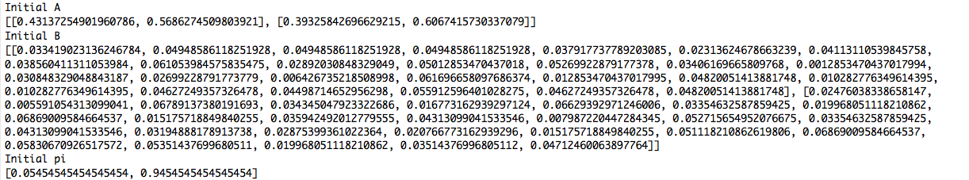

Final Values for A, B and Pi for N = 2

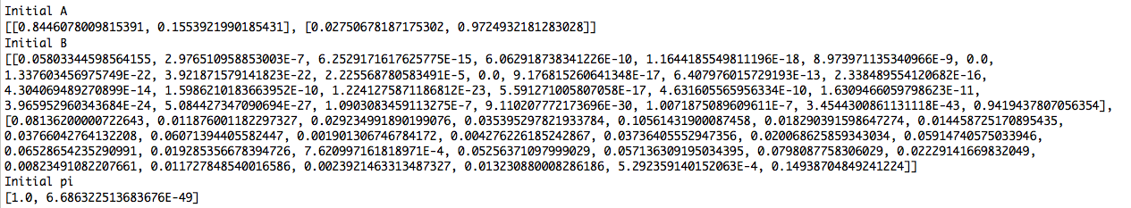

N = 3

Initial Values for A, B and Pi for N = 3

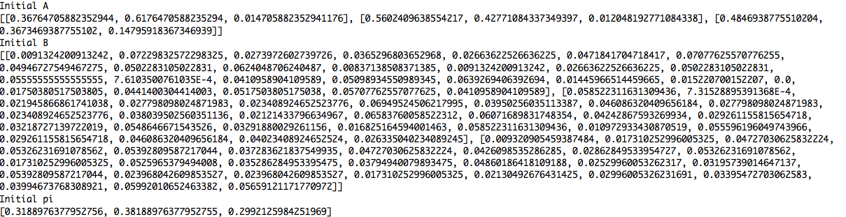

Final Values for A, B and Pi for N = 3

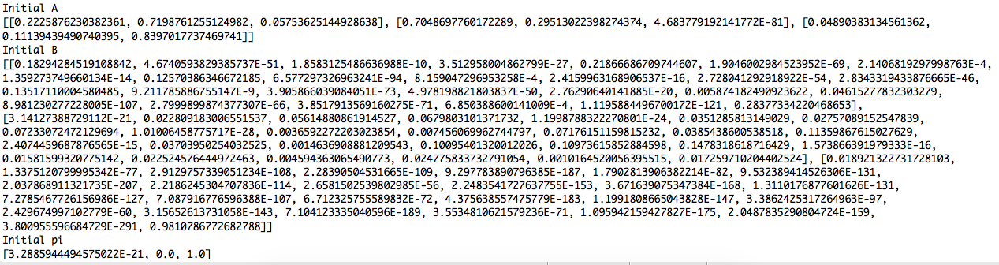

N = 4

Initial Values for A, B, pi for N = 4

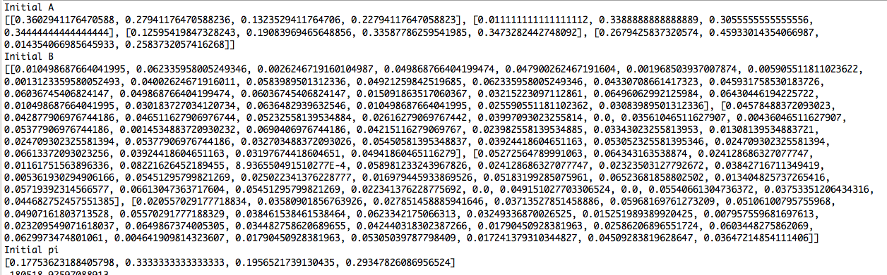

Final Values for A, B and Pi for N = 4

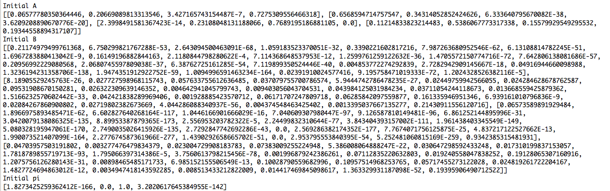

N = 26

Initial Matrix A, B, pi for N = 26

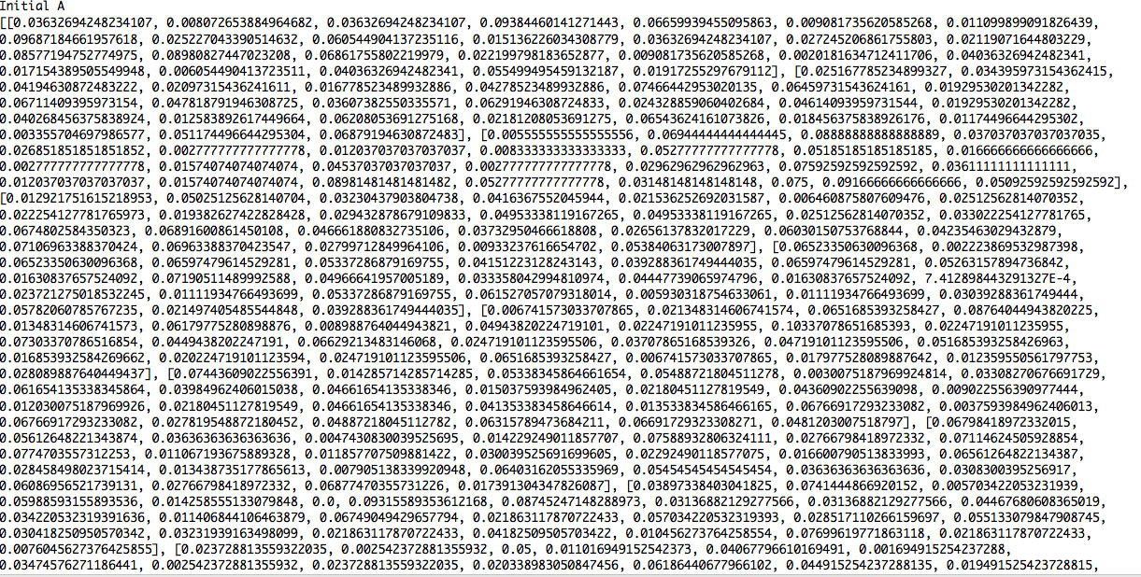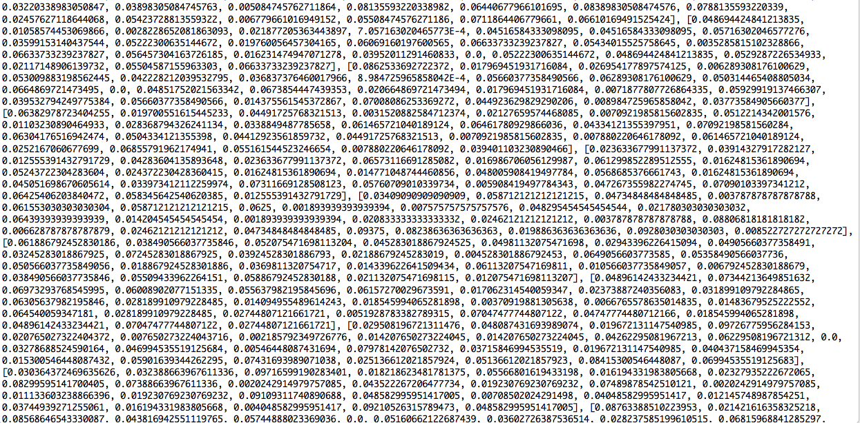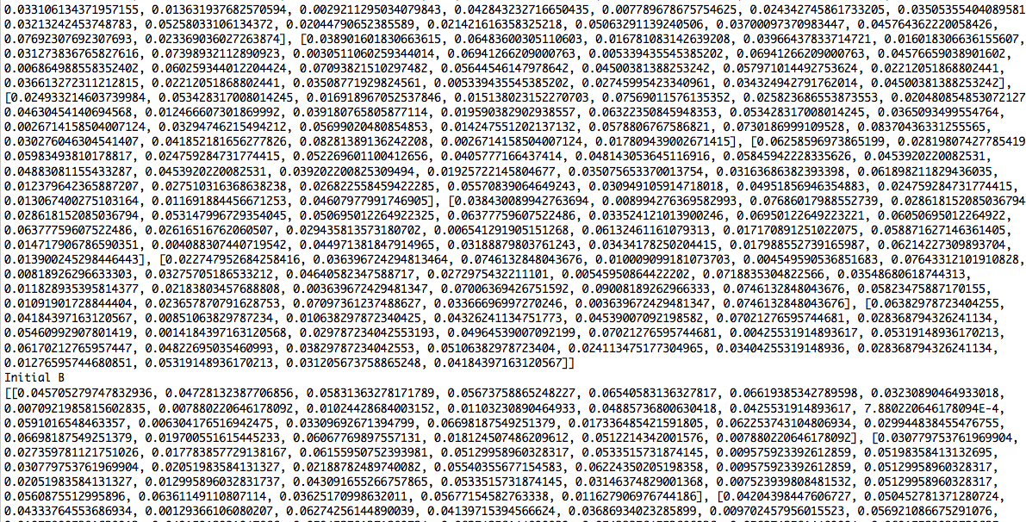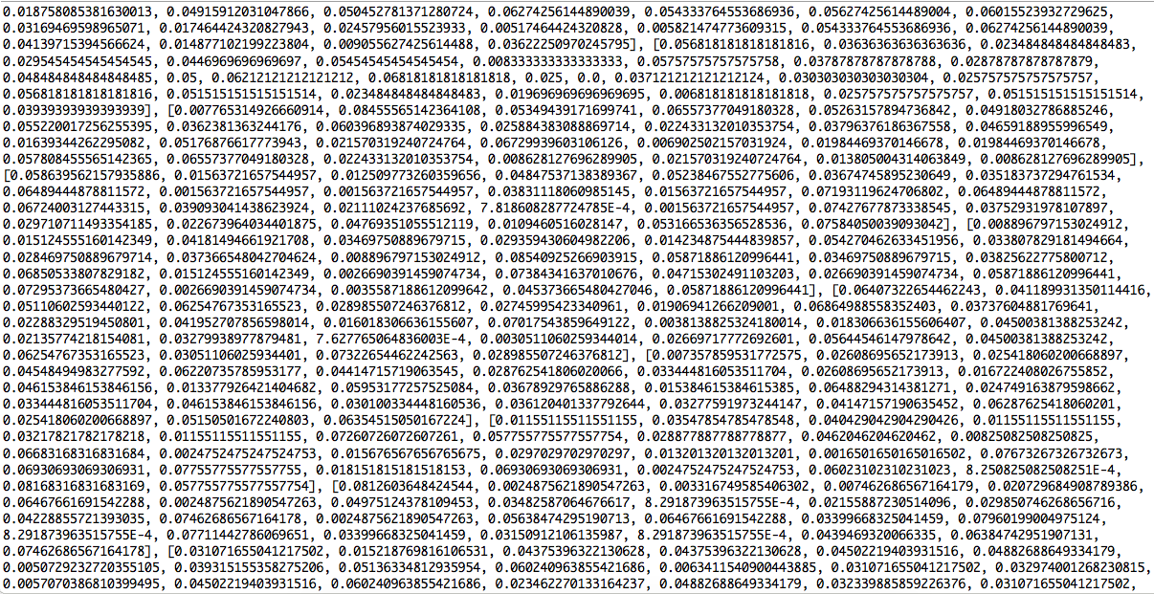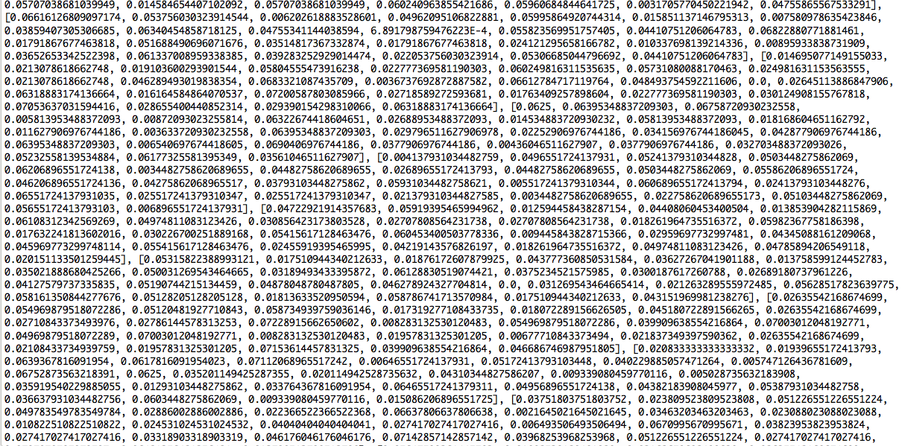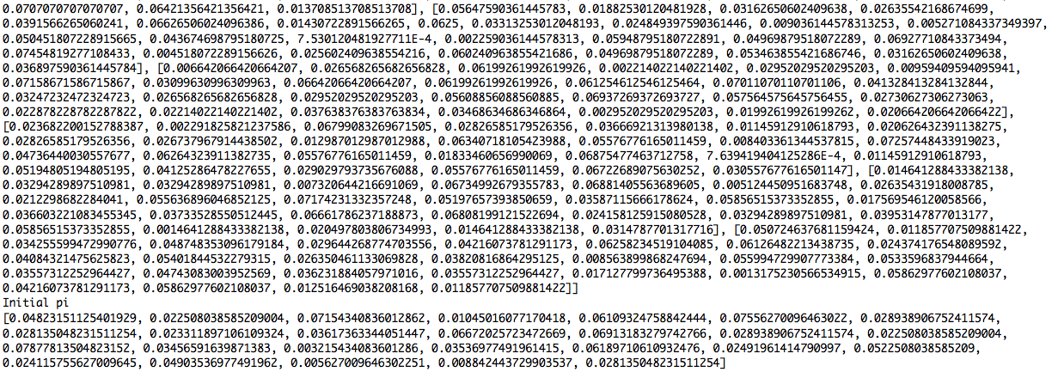

Final Matrix for A, B, pi for N = 26

